WT Lab (HTML Assignment )

By:- Anusthan Singh (20051337) Cse-9

Assigment -1

Date:- 11/1/2022m

1. Write a Html program to design a **Introduction Form**

HTML Code:-

<!DOCTYPE html>

<html lang="en">

<head>

    <meta charset="UTF-8">

    <meta http-equiv="X-UA-Compatible" content="IE=edge">

    <meta name="viewport" content="width=device-width, initial-scale=1.0">

    <title>Introduction Page</title>

</head>

<body bgcolor="FFFACD" >

    <header> <center> This is my first class Of Wt lab introduction page </center></header>

<!-- A Code by Anusthan Singh (20051337) Cse 9 -->

   <div style="color: purple;" >

    <center>

   <h1> <b> By Anusthan Singh (blot)</b> </h1>

   <h2> <em> Roll No 20051337 (italics) </em> </h2>

   <h3> <u> Cse 9 (underline) </u></h3>

    <a href="https://www.instagram.com/anusthan_12/"> Follow me on instagram! </a>

    <br>

    <span> School of Computer science</span>

    </center>

    </div>

    <br>

    <hr>

    <p> Using Marquee </p>

    <header> <center> KIIT CSE REGISTRATION FORM </center> </header>

    <marquee behavior="slide" direction="left" loop="infnite"  > REGISTRATER NOW!  </marquee>

    <marquee behavior="slide" direction="right" loop="infnite" > REGISTRATER NOW!  </marquee>

    <marquee width="60%" direction="up" height="100px" loop="infnite"> REGISTRATER NOW! </marquee>

    <marquee width="60%" direction="down" height="100px" loop="infnite"> REGISTRATER NOW! </marquee>

    <hr>

    <br>

    <hr>

    <h1> <center> Information </center></h1>

    <p> FirstName: <input type="text" name="FirstName" ></p>

    <p> Middlename: <input type="text" name="Middlename"></p>

    <p> lastname: <input type="text" name="Lastname"></p>

    <fieldset> <legend> Gender</legend>

        <p>

            Male <input type="radio" name="Gender" id="Male">

            <br>

            Female <input type="radio" name="Gender" id="Female">

            <br>

            Other <input type="radio" name="Gender" id="Other">

        </p>

</fieldset>

    <br>

    <fieldset> <legend> Course</legend>

    <select name="Course" id="Course">

    <option value="">Choose Your Course</option>

    <option value="Engg">Engg</option>

    <option value="Medical">Medical</option>

    <option value="BAA">BBA</option>

    <option value="BCOM">BCOM</option>

    <option value="Arts">Arts</option>

</select>

</fieldset>

  <p> Phone: <input type="Number" name="number" id="number"></p>

  <p> Address: <br> <textarea name="Address" id="" cols="30" rows="7"></textarea>

  <p> Email: <input type="email" name="Email" id="Email"></p>

  <p> password: <input type="password" name="Password" id="Password"> </p>

  <p> Repassword: <input type="password" name="RePassword" id="RePassword"> </p>

  <input type="submit" value="Submit">

<!-- A Code by Anusthan Singh (20051337) Cse 9 -->

<hr>

<br>

<img src="C:\Users\KIIT\OneDrive\Desktop\complete web dev\kiit wt lab\1.11.2022/panner.jpg" alt="say panner" width="40%" height="50%">

<hr>

<br>

<center> List  </center>

<h3> State city</h3>

<ul>

    <li> maharastra</li>

</ul>

    <li> mumbai</li>

    <li>pune</li>

    <li> nagpur</li>

    <li> nasik</li>

    <ul>

        <li> utter pradesh</li>

    </ul>

        <li> lucknow</li>

        <li> ayodhaya</li>

        <li> kanpur</li>

        <li> gorkhpur</li>

        <ul>

            <li> karnataka</li>

        </ul>

            <li> banglore</li>

            <li> mysure</li>

            <li> hebuli</li>

            <ul>

                <li> goa</li>

            </ul>

                <li> panji</li>

                <li> ponda</li>

                <li> peram</li>

                <ul>

                    <li> tamil nadu</li>

                </ul>

                    <li> chennai</li>

                    <li> trichi</li>

                    <li> tirupati</li>

                    <ul>

<!-- A Code by Anusthan Singh (20051337) Cse 9 -->

</body>

</html>

Output Screenshot:-

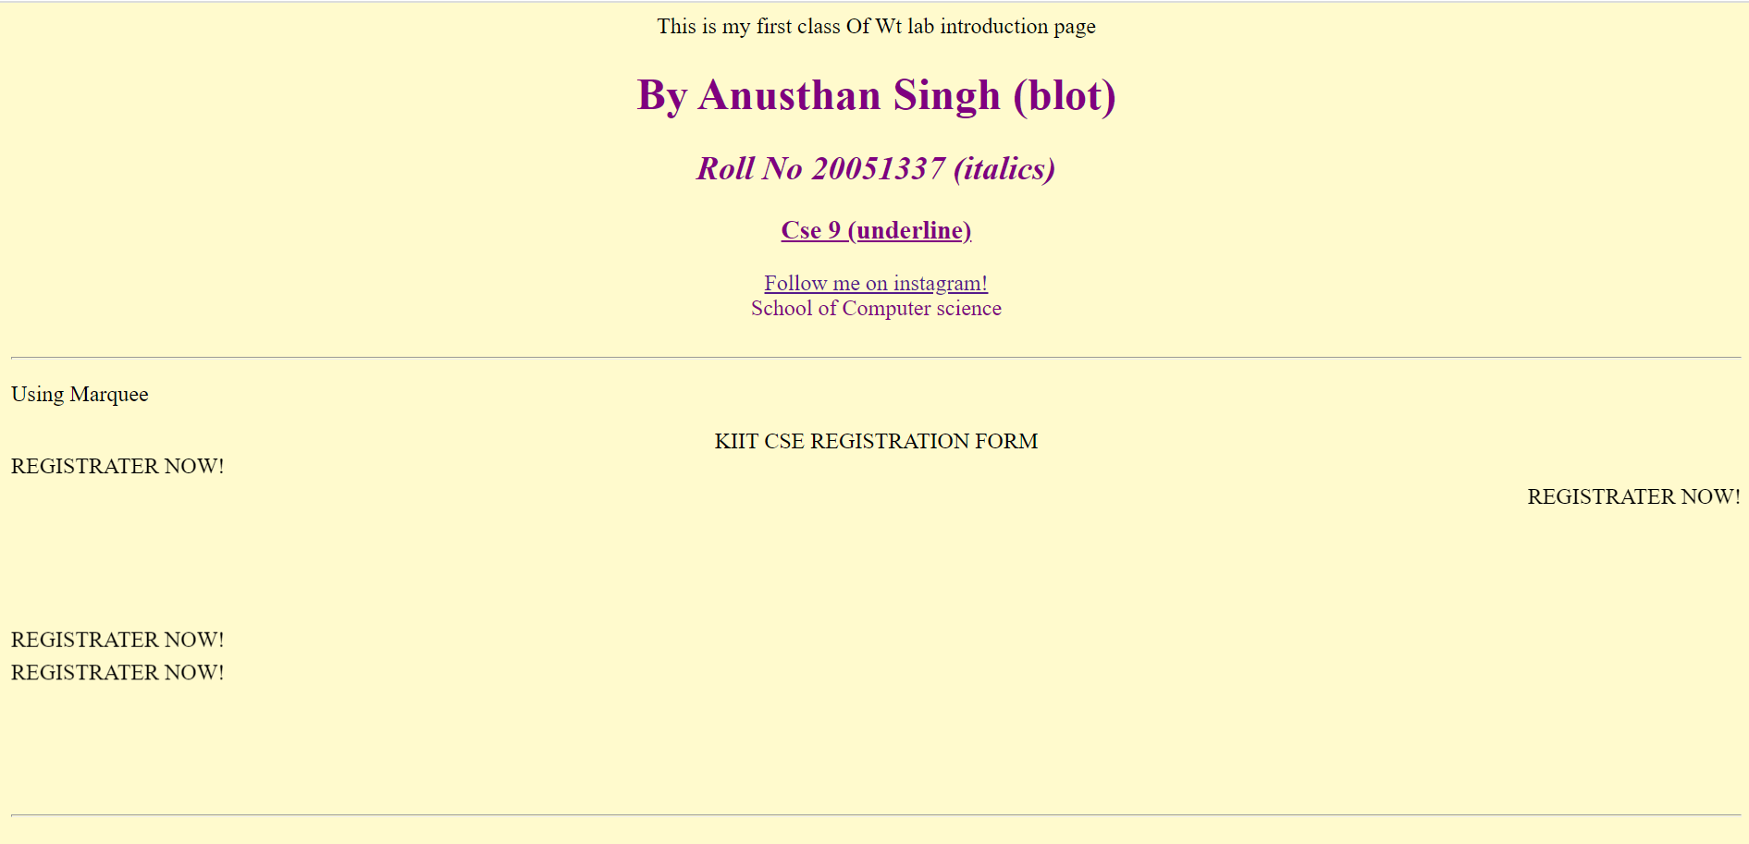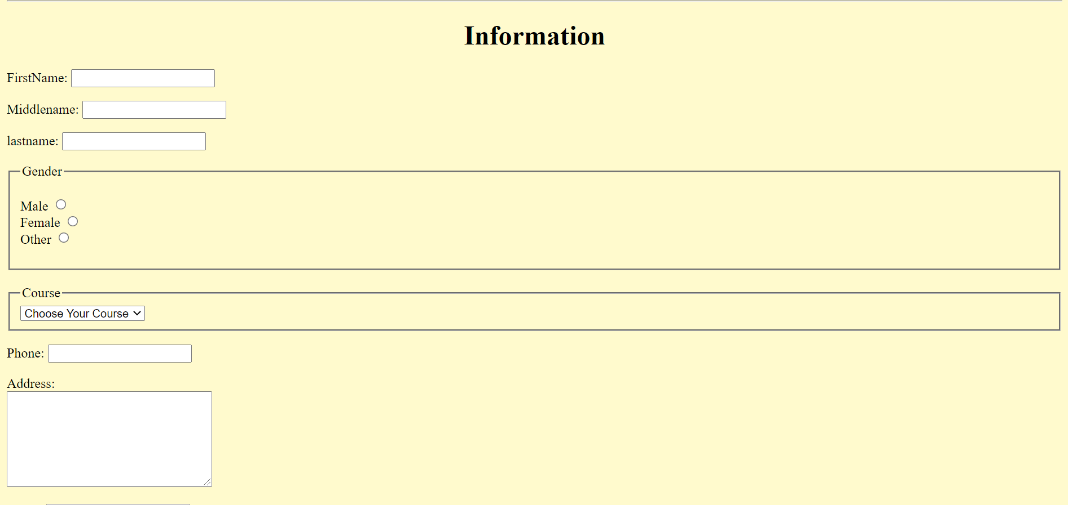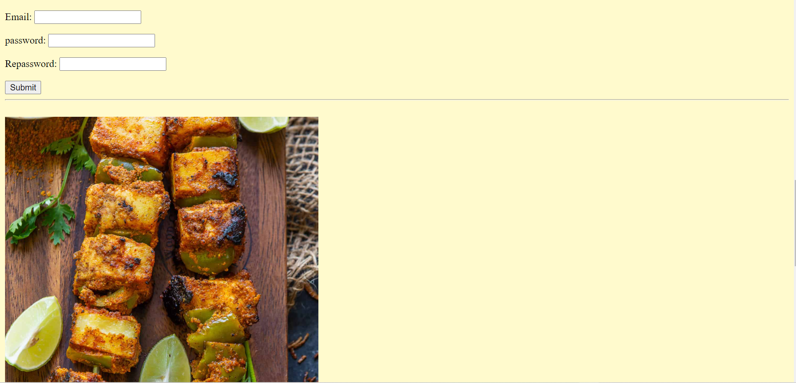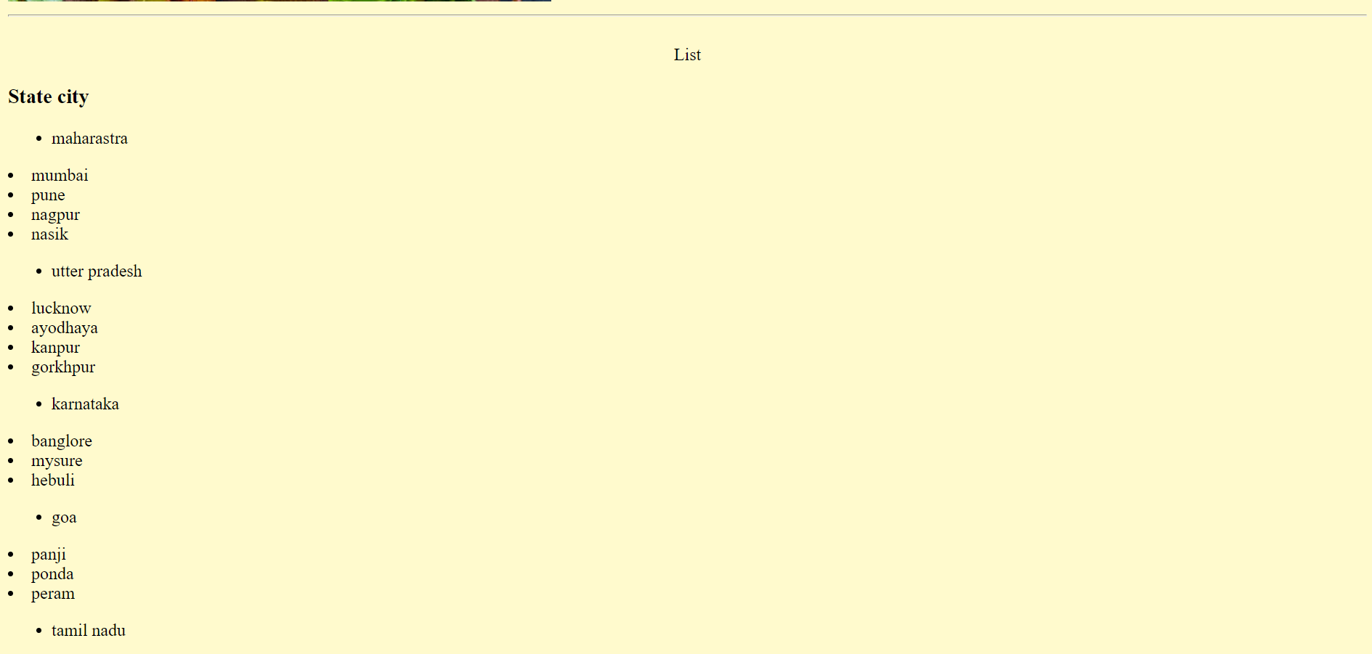

Assigment- 2

Date:- 18/1/2022

1. Write a Html program to design a **Biodata form**

HTML form:-

<!DOCTYPE html>

<html lang="en">

<head>

    <meta charset="UTF-8">

    <meta http-equiv="X-UA-Compatible" content="IE=edge">

    <meta name="viewport" content="width=device-width, initial-scale=1.0">

    <title>Bio-Data</title>

    <link rel="stylesheet" href="biodata.css">

</head>

<body>

    <div class="container">

    <header> <h1> <b> <u> <center> BIO-DATA </center></u></b></h1></header>

    <br>

<!-- A Code by Anusthan Singh (20051337) Cse 9 -->

     <fieldset>

         <legend> About me</legend>

    <p>Name : &emsp; &emsp;  Anusthan Singh  </p>

    <p>Father's Name : &emsp; &emsp;  Ajay  Singh  </p>

    <p>Mother's Name : &emsp; &emsp;  Manorama  Singh  </p>

    <br>

    <p> Address : &emsp;  Plot 64,65 bhagrathi park near suitgirni Dmart hingna road nagpur </p>

    <p> Contact : &emsp; &emsp;  +9312378921 </p>

    <p> DOB : &emsp; &emsp;  12th Oct 2001</p>

        <p> National Id :&emsp; &emsp;  1450xxxxxxxxxx</p>

        <p> E-mail : &emsp; &emsp;  20051337@kiit.ac.in</p>

        <p> Religion :&emsp; &emsp;  Hindu</p>

        <p> Nationalty :&emsp; &emsp;  Hindustan</p>

        <p> Marital status :&emsp; &emsp;  Unmarried</p>

        <br>

        <p>Hobbies: &nbsp; Collecting rare Things, Big fan of cinemas,Traveling, Driving Enthusiast</p>

        <br>

        <p>Languages : &emsp;  Hindi &nbsp; English &nbsp; Bhojpuri (newbie) &nbsp; marathi (newbie) &nbsp; Germani (newbie) </p>

        <br>

        <p> Education  &emsp;  : B.tech(C.S.E) (persuing)</p>

        <br>

        <p> Computer knowledge  &emsp; &emsp; : Ms office (advance) &nbsp; DBMS &nbsp; Web devlopment &nbsp; C++ language &nbsp; Autocad</p>

        <br>

        <p> Achivment  &emsp; &emsp; : Founder of link for works  <a href="https://chat.whatsapp.com/DFnHLP1kawoBNSUolL3AsU">Wana join</a></p>

        </fieldset>

        <a href="https://www.instagram.com/anusthan_12/"> Follow me on instagram! </a>

        <br>

<!-- A Code by Anusthan Singh (20051337) Cse 9 -->

        <p> Fav food  &emsp; &emsp; : Indian cusine BBQ</p>

        <img src="C:\Users\KIIT\OneDrive\Desktop\complete web dev\kiit wt lab\1.11.2022\panner.jpg" alt="say panner" width="40%" height="50%">

        <input type="submit" value="Ok! Done Click Here to Close

">

        </div>

</center>

</body>

</html>

CSS code:-

*{

    box-sizing: border-box;

}

body{

    font-family: Verdana, Geneva, Tahoma, sans-serif;

    margin: 15px 30px;

    font-size: 17px;

    padding: 8px;

    text-align: center;

}

.container{

    background-color: #faebd7;

    padding: 5px 20px 15px 20px;

    border: 1px solid red;

    border-style:alotted solid double dashed;

}

input[type="text"],

input[type="email"],

input[type="number"],

input[type="password"],

input[type="date"],

select,

textarea{

    width: 100%;

    padding: 12px;

    border: 1px solid orchid;

    border-radius: 5px;

}

fieldset{

    background-color: snow;

    border: 1px solid khaki;

}

<!-- A Code by Anusthan Singh (20051337) Cse 9 -->

main_heading{

    text-align: center;

}

input[type="submit"]{

    background-color: greenyellow;

    color: rebeccapurple;

    padding: 12px 20px;

    border: none;

    border-radius: 4px;

    cursor: pointer;

    width: 100%;

}

Output Screenshot:-

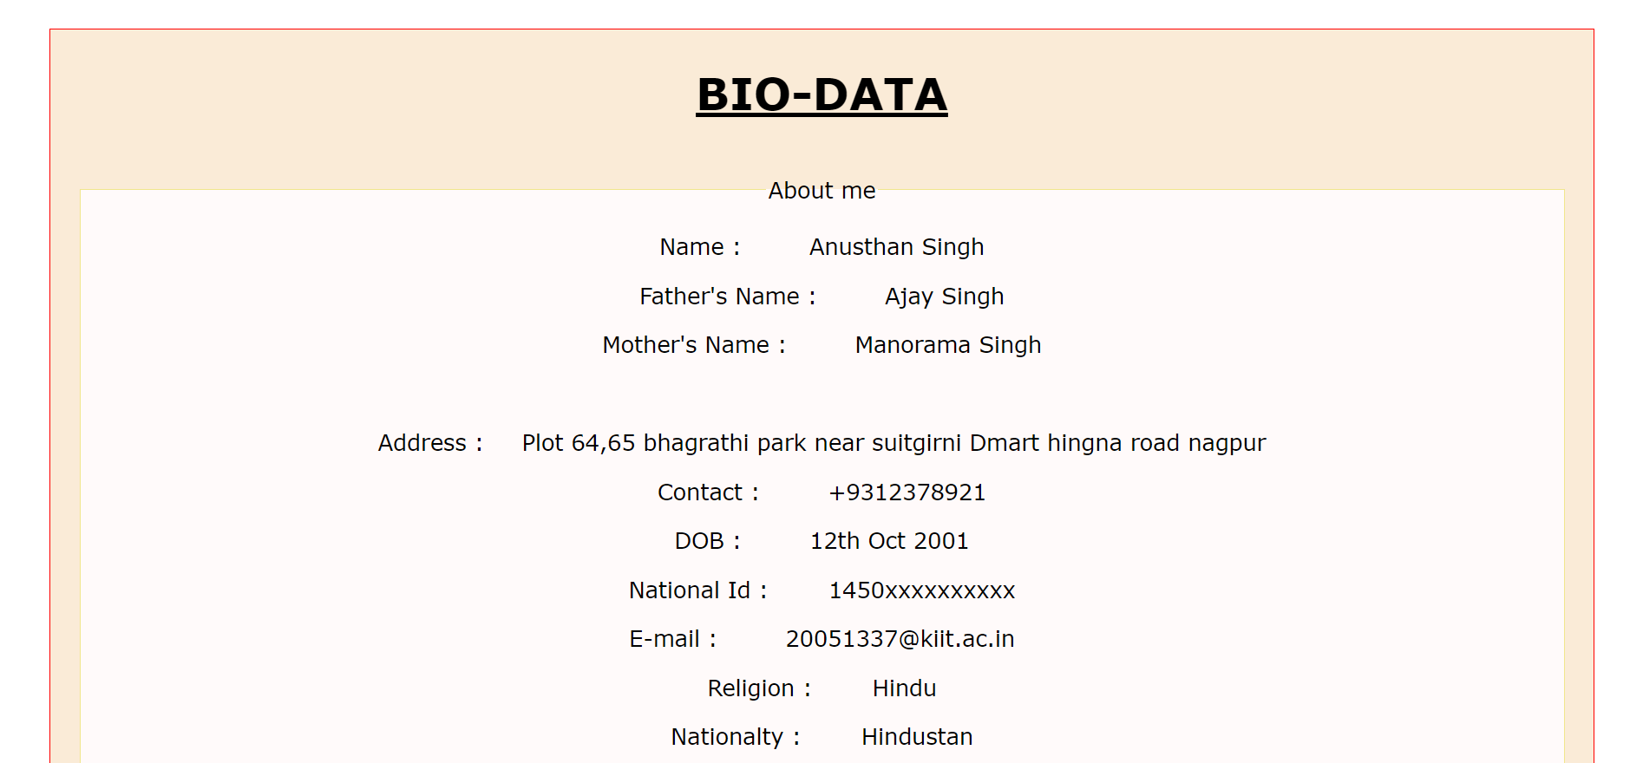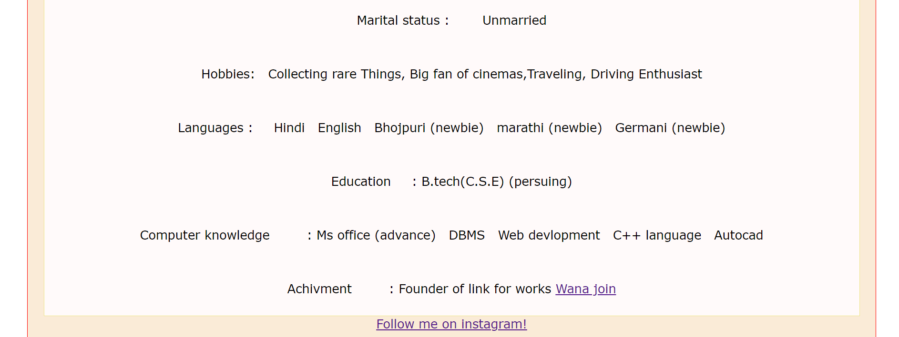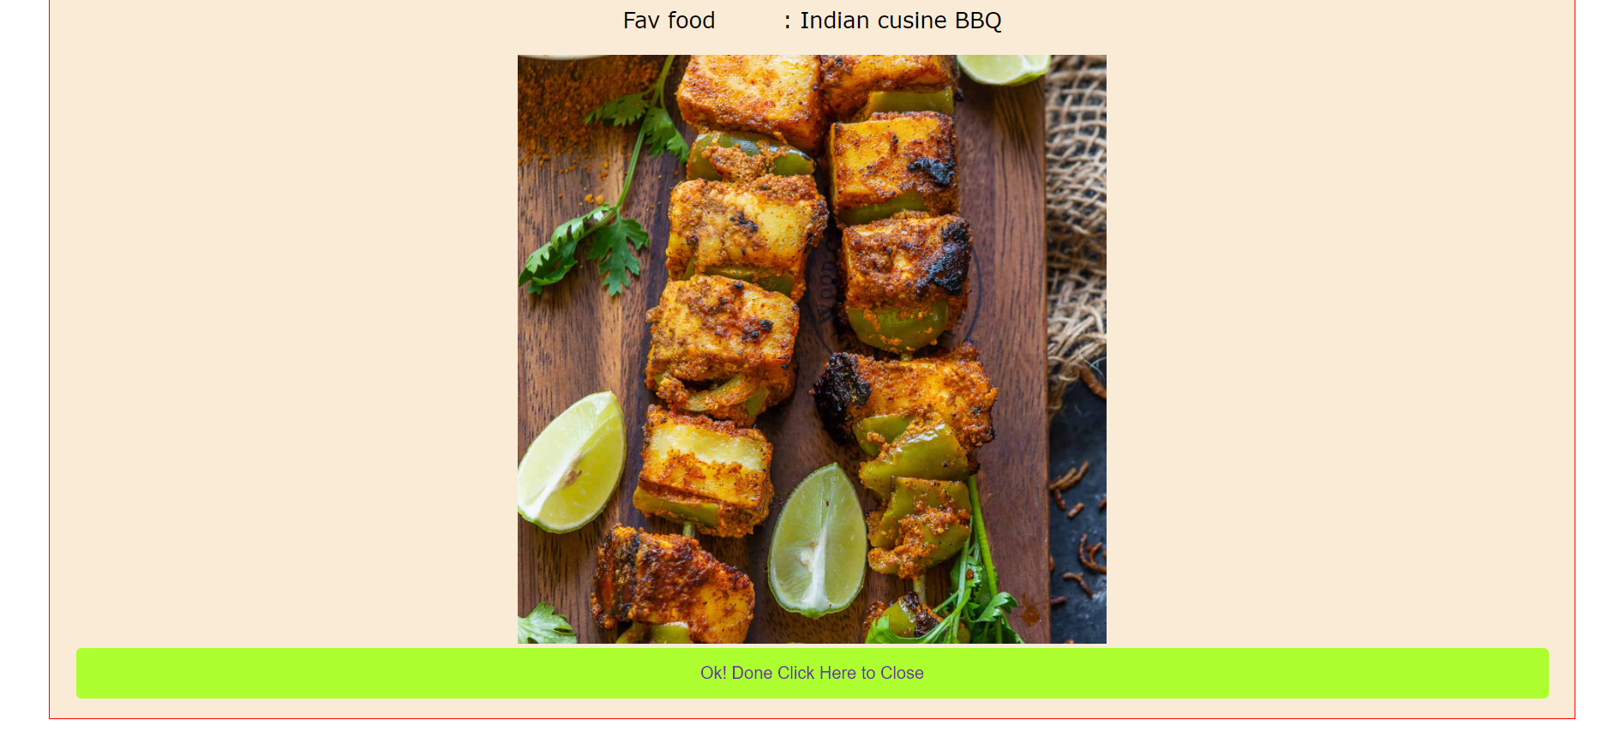

Assignment – 3

Date:- 25/1/2022

Lab 2

Example 1:-

Create a web page as follows: having 3 frames. KIIT University will move in marquee in the top frame. In the left frame 3 hyperlinks named Login, About KIIT and Feedback will be there and clicking on that the desired result will be displayed in the main frame.

Main file html Code:-

<!DOCTYPE html>

<html lang="en">

<head>

    <meta charset="UTF-8">

    <meta http-equiv="refresh" content="5">

    <meta name="viewport" content="width=device-width, initial-scale=1.0">

    <title>Lab2_Q1</title>

    <style>

        A:hover, link:hover, Content:hover {

            color: purple;

        }

    </style>

</head>

<!-- A Code by Anusthan Singh (20051337) Cse 9 -->

<Frameset rows="25%,*">

    <Frameset cols="*">

     <frame name="A" src="heading_kiit.html" scrolling="no" marginwidth="0" marginheight="0"  >

    </Frameset>

    <Frameset cols="20%, *">

        <frame name="link" src="link_Left_side.html" scrolling="no"  marginwidth="0" marginheight="0" >

        <frameset rows="70">

        <frame name="Content"  scrolling="no" marginwidth="0" marginheight="0" >

    </frameset>

    </frameset>

</html>

Heading KIIT HTML Code:-

<!DOCTYPE html>

<html lang="en">

<head>

    <meta charset="UTF-8">

    <meta http-equiv="X-UA-Compatible" content="IE=edge">

    <meta name="viewport" content="width=device-width, initial-scale=1.0">

    <title>Document</title>

    <style>

        h2{

            text-align: center;

        }

        body

        { <!-- A Code by Anusthan Singh (20051337) Cse 9 -->

            background-size: cover;

        }

        </style>

    </head>

    <body>

<div class="Container">

        <br>

        <br>

        <h2>

            KALINGA INSTITUTE OF INDUSTRIAL TECHNOLOGY

        </h2>

  <b><marquee behavior="alternate" direction="left">KIIT University,  Bhubaneswar, India

        </b></marquee>

    </body>

</div>

</html>

Link left Side HTML code:-

<!DOCTYPE html>

<html lang="en">

<head>

    <meta charset="UTF-8">

    <meta http-equiv="X-UA-Compatible" content="IE=edge">

    <meta name="viewport" content="width=device-width, initial-scale=1.0">

    <title>link</title>

    <style>

        body{

          background-image: url(8.jpg);

          background-size: cover;

        }

        h3,a{ <!-- A Code by Anusthan Singh (20051337) Cse 9 -->

            margin-top: 10vh;

            margin-left: 15vw;

        }

        </style>

</head>

<body>

    <h3>

        <a href="https://kiitportal.kiituniversity.net/irj/portal/" target="Content">Login</a>

        <br>

        <br>

        <a href="https://en.wikipedia.org/wiki/Kalinga_Institute_of_Industrial_Technology" target="Content">About</a>

        <br>

        <br>

        <a href="https://iqac.kiit.ac.in/pdf/forms/FEEDBACK-FROM-PARENTS.pdf" target="Content">Feedback</a>

        <br>

        <br>

    </h3> <!-- A Code by Anusthan Singh (20051337) Cse 9 -->

</body>

</html>

Output Screenshot :-

  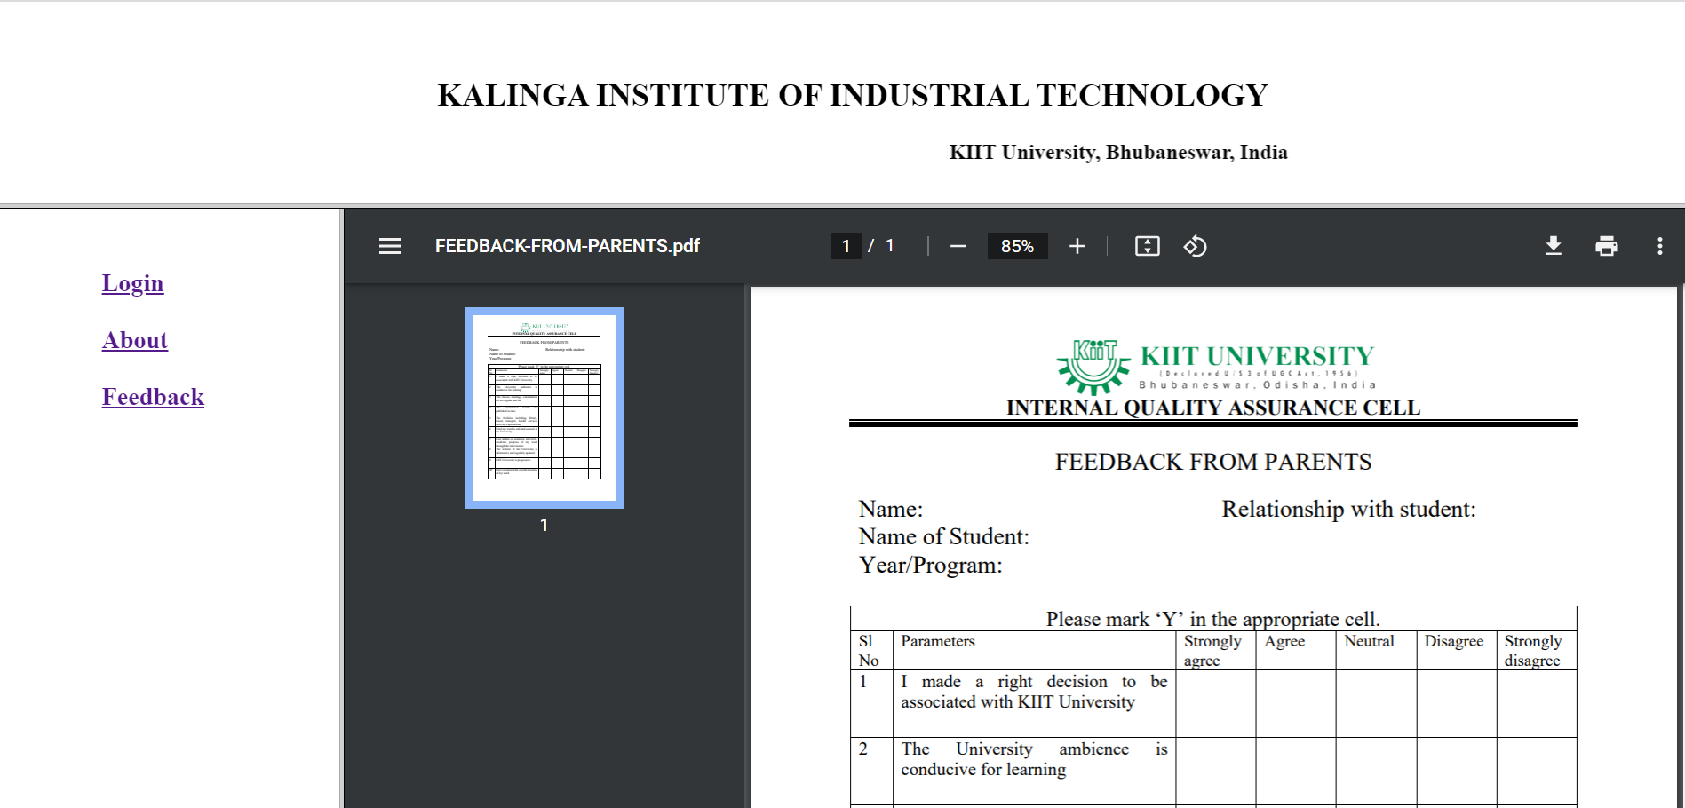

Example 2:-

2 Create a web page using Ordered, Unordered, Directory and Nested List which will display the output as follows

HTML Code:-

<!DOCTYPE html>

<html lang="en">

<head>

    <meta charset="UTF-8">

    <meta http-equiv="X-UA-Compatible" content="IE=edge">

    <meta name="viewport" content="width=device-width, initial-scale=1.0">

    <title>List</title>

</head>

<body>

<!-- A Code by Anusthan Singh (20051337) Cse 9 -->

    <ul >

        <li> Coffee</li>

        <li> Tea</li>

        <li> Milk</li>

    </ul>

    <ul type="circle" >

        <li> Coffee</li>

        <li> Tea</li>

        <li> Milk</li>

    </ul>

    <ul type="square" >

        <li> Coffee</li>

        <li> Tea</li>

        <li> Milk</li>

    </ul>

    <br>

    <ol type="A">

        <li> Coffee</li>

        <li> Tea</li>

        <li> Milk</li>

    </ol>

    <ol type="1">

        <li> Coffee</li>

        <li> Tea</li>

        <li> Milk</li>

    </ol>

    <ol type="i">

        <li> Coffee</li>

        <li> Tea</li>

        <li> Milk</li>

    </ol>

    <br>

        <td>

            <ul type="None">

                <li>Coffee</li>

                <ul type="None">

                    <li>- black hot drink</li>

                </ul>

                <li>Milk</li>

                <ul type="None">

                    <li>- White hot drink</li>

                </ul>

            </ul>

        </td>

  <ul>

      <li>Item A</li>

      <li>Item B

          <ul>

              <li>Subtem B,1</li>

              <li>Subtem B,2</li>

          </ul>

      </li>

      <li>Item C</li>

  </ul>

<!-- A Code by Anusthan Singh (20051337) Cse 9 -->

</ul>

</body>

</html>

Output:-  
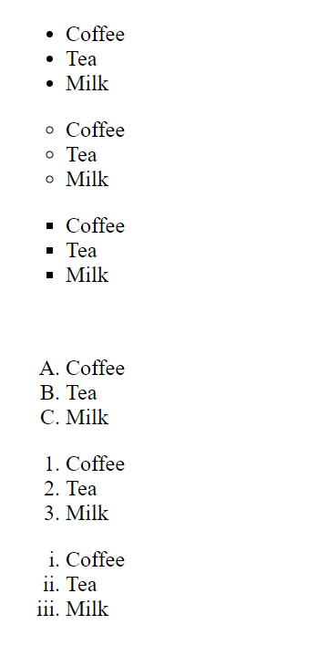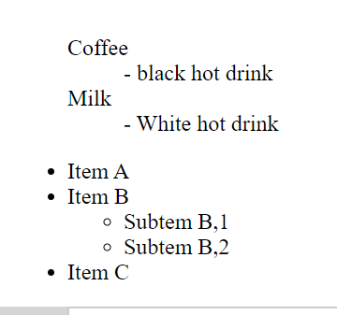

Example 3:-

Design a web page using inline style applied on <h> tag using style attribute which will display the following output:

Html Code:-

<!DOCTYPE html>

<html lang="en">

<head>

    <title>q3</title>

    <meta charset="UTF-8">

    <meta http-equiv="X-UA-Compatible" content="IE=edge">

    <meta name="viewport" content="width=device-width, initial-scale=1.0">

    <title> Lab 2 Example 3 </title>

<!-- A Code by Anusthan Singh (20051337) Cse 9 -->

</head>

<body>

    <h1 style="text-decoration: underline; color: red; text-align: center; " > KIIT University</h1>

</body>

</html>

Output:-



Example - 4 Design the same web page as shown in Example - 3 using internal style sheet.

HTML Code:-

<!DOCTYPE html>

<html lang="en">

<head>

 <meta charset="UTF-8"> <meta http-equiv="X-UA-Compatible" content="IE=edge">

<meta name="viewport" content="width=device-width, initial-scale=1.0">

<title>q4</title>

<style>

body

{text-align: center;

 color: red; }

</style>

</head> <!-- A Code by Anusthan Singh (20051337) Cse 9 -->

<body>

<div><h1> <b> <u>KIIT UNIVERSITY</u> </b> </h1> </div>

</body> </html>

Output:-



Example - 5 Design the same web page as shown in Example - 3 using external style sheet.

Html Code:-

<!DOCTYPE html>

<html lang="en">

<head>

    <title>q5</title>

    <meta charset="UTF-8">

    <meta http-equiv="X-UA-Compatible" content="IE=edge">

    <meta name="viewport" content="width=device-width, initial-scale=1.0">

    <link rel="stylesheet" href="q5.css">

    <title>Q5</title>

</head>

<body>

<!-- A Code by Anusthan Singh (20051337) Cse 9 -->

    <h1>KIIT University</h1>

</body>

</html>

External (Css) Code

*{

    box-sizing: border-box;

}

<!-- A Code by Anusthan Singh (20051337) Cse 9 -->

h1

{

    text-align: center;

    text-decoration: red underline;

<!-- A Code by Anusthan Singh (20051337) Cse 9 -->

    color: red;}

Output:-



Lab 3

Example - 1 Create a webpage to display the following student table.

HTML Code:-

<!DOCTYPE html>

<html lang="en">

<head>

    <meta charset="UTF-8">

    <meta http-equiv="X-UA-Compatible" content="IE=edge">

    <meta name="viewport" content="width=device-width, initial-scale=1.0">

    <title>Student table</title>

</head>

<body>

<!-- A Code by Anusthan Singh (20051337) Cse 9 -->

    <center>

        <h3 style="text-align:center;">STUDENT MARKS DETAILS</h3>

        <table border=1 style="width:500">

        <tr>

        <th>Roll No</th>

        <th>Name</th>

        <th colspan="2">Subjects Wise Marks</th>

        <th>Average</th>

        <th>SGPA</th>

        <th>Grade</th>

        </tr>

        <tr>

        <td rowspan="4" style="text-align:center;">20051337</td>

        <td rowspan="4" style="text-align:center;"> Anusthan Singh</td>

        <td style="text-align:center;">Sub-1</td>

        <td style="text-align:center;">100</td>

        <td rowspan="4"style="text-align:center;">100</td>

        <td rowspan="4"style="text-align:center;">10</td>

        <td rowspan="4"style="text-align:center;">O</td>

        </tr>

        <tr>

        <td style="text-align:center;">Sub-2</td>

        <td style="text-align:center;">99</td>

        </tr>

        <tr>

        <td style="text-align:center;">Sub-3</td>

        <td style="text-align:center;">98</td>

        </tr>

        <tr>

        <td style="text-align:center;">Sub-4</td>

        <td style="text-align:center;">105</td>

        </tr> <!-- A Code by Anusthan Singh (20051337) Cse 9 -->

        </table>

</body>

</html>

Output:-

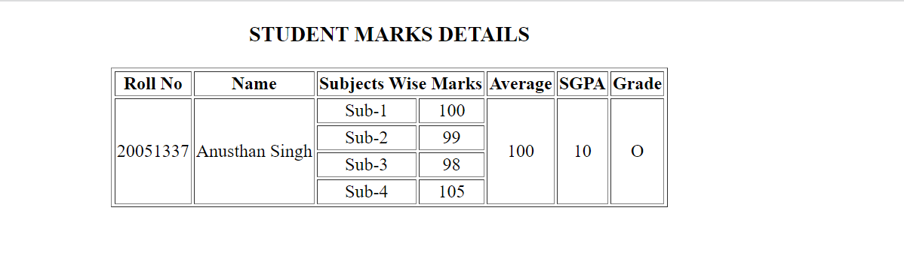

Example – 2 Design the following table using colspan and rowspan

Html Code:-

<!DOCTYPE html>

<html lang="en">

<head>

    <meta charset="UTF-8">

    <meta http-equiv="X-UA-Compatible" content="IE=edge">

    <meta name="viewport" content="width=device-width, initial-scale=1.0">

    <title>ABCD Table lab3ex2</title>

</head>

<body> <!-- A Code by Anusthan Singh (20051337) Cse 9 -->

    <center>

        <table border=1px style="width: 200px;">

        <tr>

        <td colspan="3"style="text-align:center">A</td>

        </tr>

        <tr>

        <td rowspan="2"style="text-align:center">B</td>

        <td colspan="2"style="text-align:center">C</td>

        </tr>

        <tr>

        <td style="text-align:center">D</td>

        <td style="text-align:center">E</td>

        </tr>

        </table>

</body>

</html>

Output:-

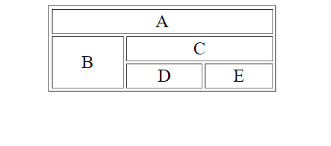

Example - 3 Design a user registration form in HTML.

Html Code:-

<!DOCTYPE html>

<html lang="en">

<head>

    <meta charset="UTF-8">

    <meta http-equiv="X-UA-Compatible" content="IE=edge">

    <meta name="viewport" content="width=device-width, initial-scale=1.0">

    <title>Challengeform</title>

    <link rel="stylesheet" href="form.css">

</head>

<body bgcolor="#faebd7">

    <h1 > <center> Student Registration form ! </center></h1>

     <br>

     <hr>

    <h2> Personal details</h2>

    <p> <!-- A Code by Anusthan Singh (20051337) Cse 9 -->

        Full Name:&nbsp;<input type="text" name="name" id="name" placeholder="Enter First Name"> &nbsp;

        <input type="text" name="name" id="name" placeholder="Enter Second Name"> &nbsp;

        <input type="text" name="name" id="name" placeholder="Enter last Name">

    </p>

    <p> Email <input type="email" name="emailaddress" id="email00"placeholder="Enter Email" ></p>

    <p> Password <input type="password" name="pass" id="password00" placeholder="Enter Password"></p>

    <p> DOB <input type="date" name="DOB" id="DOB00"></p>

    <fieldset>

         <legend> Gender </legend>

        <p> <input type="radio" name="gender" id="gender"> Male</p>

        <p><input type="radio" name="gender" id="gender"> Female</p>

        <p><input type="radio" name="gender" id="gender"> Other</p>

    </fieldset>

    <p> State &nbsp;

    <select name="state" id="state" class="form-control">

        <option value="Andhra Pradesh">Andhra Pradesh</option>

        <option value="Andaman and Nicobar Islands">Andaman and Nicobar Islands</option>

        <option value="Arunachal Pradesh">Arunachal Pradesh</option>

        <option value="Assam">Assam</option>

        <option value="Bihar">Bihar</option>

        <option value="Chandigarh">Chandigarh</option>

        <option value="Chhattisgarh">Chhattisgarh</option>

        <option value="Dadar and Nagar Haveli">Dadar and Nagar Haveli</option>

        <option value="Daman and Diu">Daman and Diu</option>

        <option value="Delhi">Delhi</option>

        <option value="Lakshadweep">Lakshadweep</option>

        <option value="Puducherry">Puducherry</option>

        <option value="Goa">Goa</option>

        <option value="Gujarat">Gujarat</option>

        <option value="Haryana">Haryana</option>

        <option value="Himachal Pradesh">Himachal Pradesh</option>

        <option value="Jammu and Kashmir">Jammu and Kashmir</option>

        <option value="Jharkhand">Jharkhand</option>

        <option value="Karnataka">Karnataka</option>

        <option value="Kerala">Kerala</option>

        <option value="Madhya Pradesh">Madhya Pradesh</option>

        <option value="Maharashtra">Maharashtra</option>

        <option value="Manipur">Manipur</option>

        <option value="Meghalaya">Meghalaya</option>

        <option value="Mizoram">Mizoram</option>

        <option value="Nagaland">Nagaland</option>

        <option value="Odisha">Odisha</option>

        <option value="Punjab">Punjab</option>

        <option value="Rajasthan">Rajasthan</option>

        <option value="Sikkim">Sikkim</option>

        <option value="Tamil Nadu">Tamil Nadu</option>

        <option value="Telangana">Telangana</option>

        <option value="Tripura">Tripura</option>

        <option value="Uttar Pradesh">Uttar Pradesh</option>

        <option value="Uttarakhand">Uttarakhand</option>

        <option value="West Bengal">West Bengal</option>

        </select>

    </p>

        <!-- A Code by Anusthan Singh (20051337) Cse 9 -->

    <p> City <input type="text" name="city" id="city00"  placeholder="Enter your City"></p>

    <p> Address <br> <textarea name="address" id="address00" cols="50" rows="15"  placeholder="Enter your Perment Address"></textarea></p>

    <p> Pincode <input type="number" name="pincode" id="Pincode00"  placeholder="Enter your Pincode"></p>

    <p> Mobile Number <input type="number" name="phonenumber" id="phone00"  placeholder="Enter 10 Digit Mobile Number"></p>

    <fieldset>

    <legend> Hobbies </legend>

    <p><input type="radio" name="Studing" id="study"> study</p>

    <p><input type="radio" name="Drawing" id="art"> Drawing</p>

    <p><input type="radio" name="Dancing" id="dance"> Dancing</p>

    <p><input type="radio" name="Sketching" id="sport"> Sketching</p>

    <p><input type="radio" name="Other" id="Other"> Other &nbsp; <input type="text" name="hobbies" id="hobbies"></p>

    </fieldset> <!-- A Code by Anusthan Singh (20051337) Cse 9 -->

    <fieldset>

        <legend> Qualifaction</legend>

        <p> <input type="radio" name="qu" id="qu"> High School( 10th )</p>

        <p> <input type="radio" name="qu" id="qu"> Higher School( 12th )</p>

        <p> <input type="radio" name="qu" id="qu"> High Graduation( Bachelors )</p>

        <p> <input type="radio" name="qu" id="qu"> Post Graduation( Masters )</p>

        <p> <input type="radio" name="qu" id="qu"> Phd (Professional)</p>

        <br>

        <hr>

        <h2> <b> Payment Details</b></h2>

              <p> Card type:

                <select name="card_type" id="card_type">

                <option value="">Select-Card-Type</option>

                <option value="VISA">VISA</option>

                <option value="MASTERCARD">MASTERCARD</option>

                <option value="RUPAY">RUPAY</option>

                <option value="AMERICAN EXPRESS">AMERICAN EXPRESS</option>

                </select>

             </p>

        <!-- A Code by Anusthan Singh (20051337) Cse 9 -->

        <p> Card number <input type="Number" name="number" id="number"></p>

        <p> Expiraton Date <input type="date" name="exp" id="exp"></p>

        <p> CVV <input type="password" name="cvv" id="cvv"></p>

        <br><br>

        <input type="submit" value="Pay Now">

    </fieldset>

CSS Code:-

*{

    box-sizing: border-box;

}

body{

    font-family: Verdana, Geneva, Tahoma, sans-serif;

    margin: 15px 30px;

    font-size: 17px;

    padding: 8px;

}

.container{

    background-color: #faebd7;

    padding: 5px 20px 15px 20px;

    border: 1px solid red;

} <!-- A Code by Anusthan Singh (20051337) Cse 9 -->

input[type="text"],

input[type="email"],

input[type="number"],

input[type="password"],

input[type="date"],

select,

textarea{

    width: 100%;

    padding: 12px;

    border: 1px solid orchid;

    border-radius: 5px;

}

fieldset{

    background-color: snow;

    border: 1px solid khaki;

}

main_heading{

    text-align: center;

}

input[type="submit"]{

    background-color: greenyellow;

    color: rebeccapurple;

    padding: 12px 20px;

    border: none;

    border-radius: 4px;

    cursor: pointer;

    width: 100%;

}

Output Screenshot:-

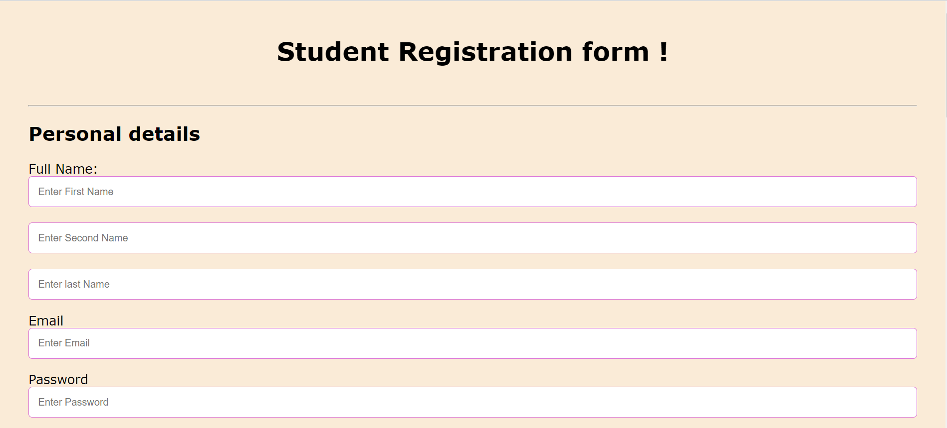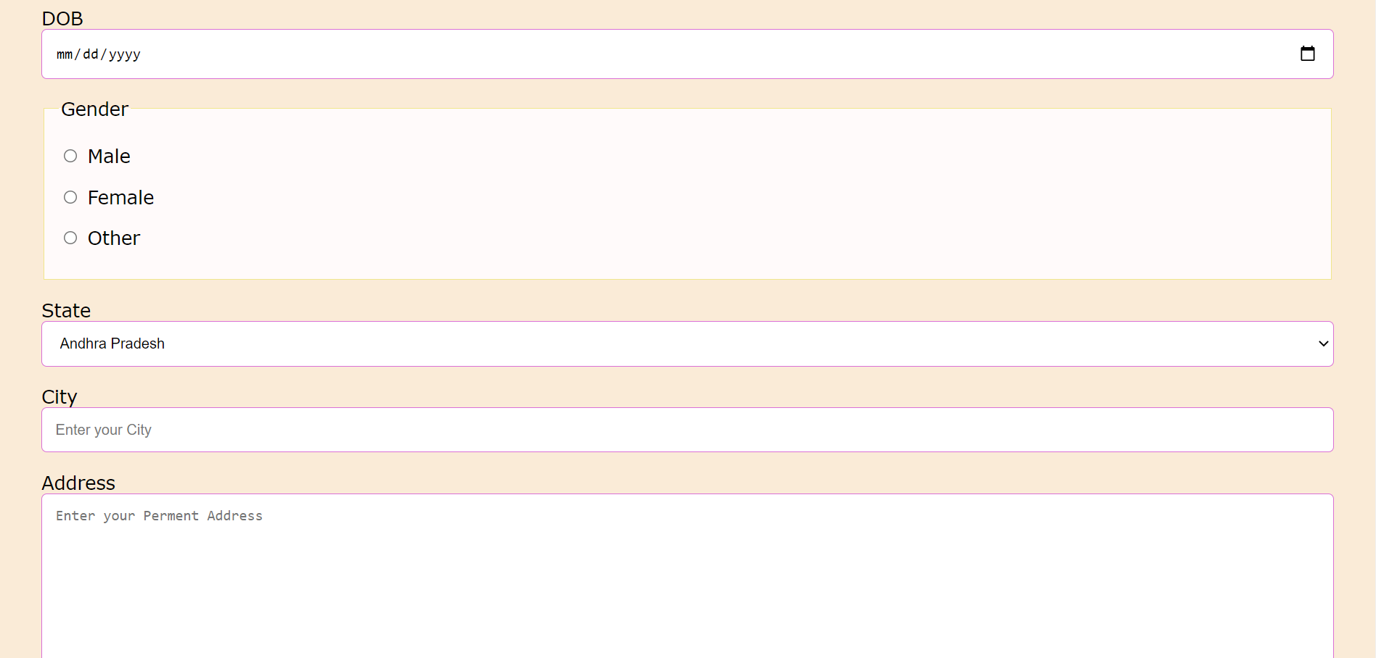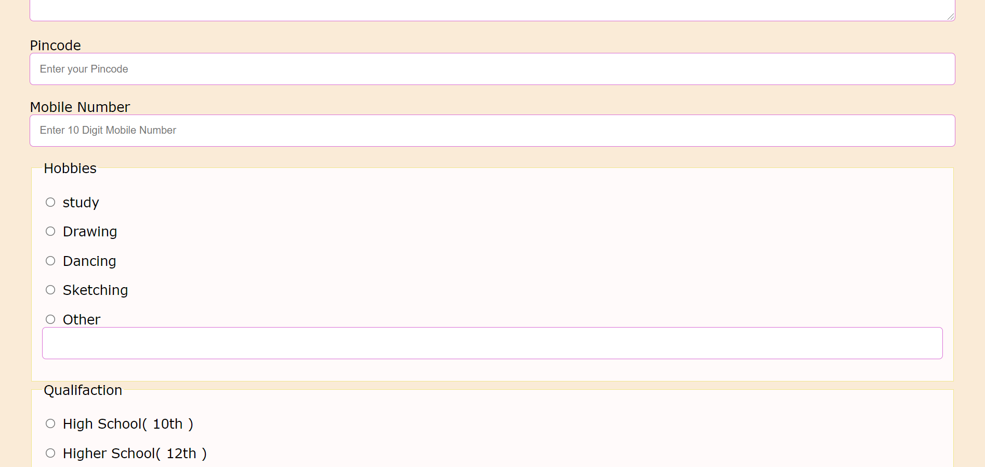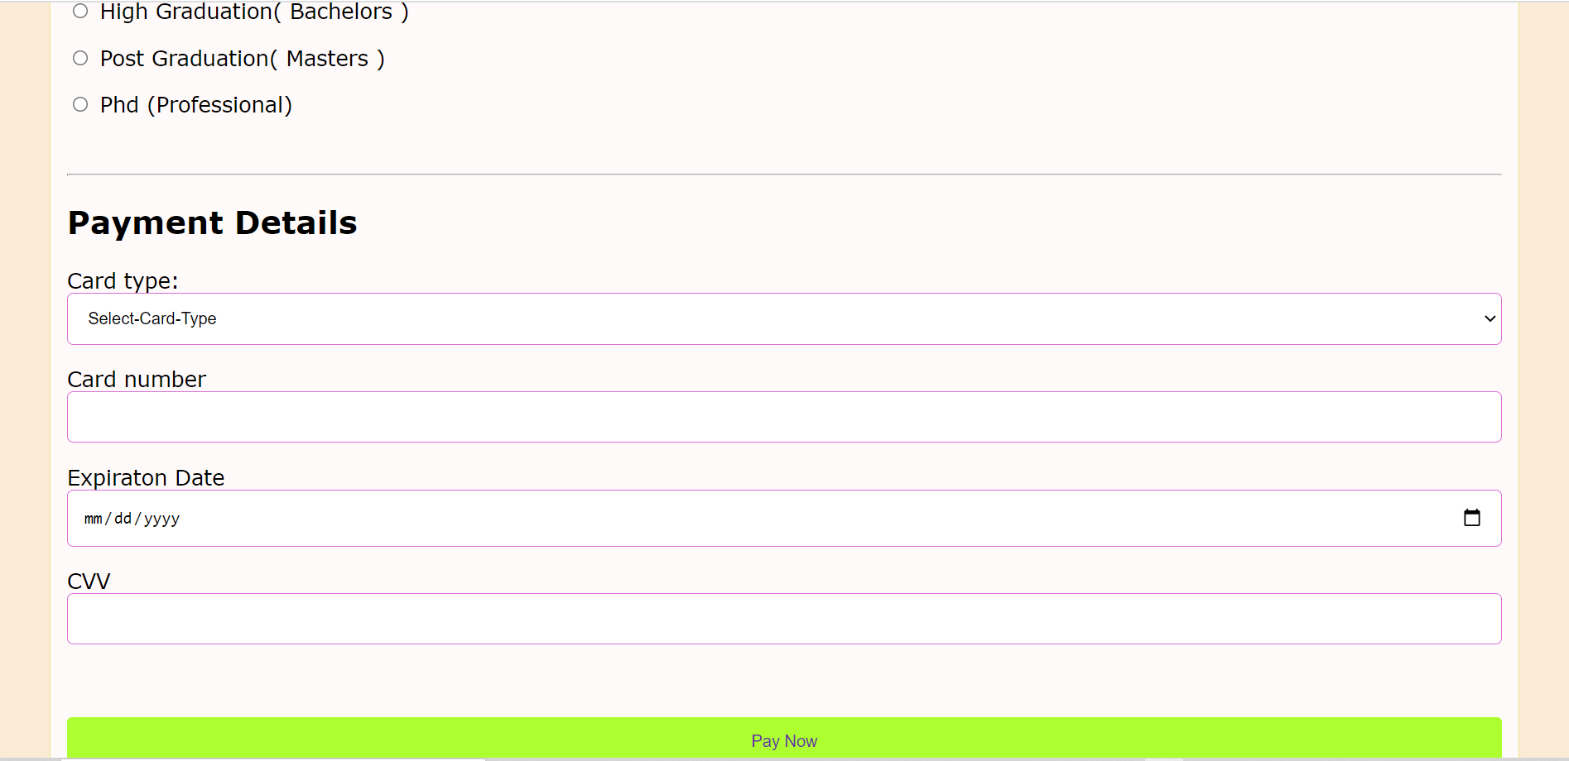

****************************The End***************************************

By:- Anusthan Singh (20051337) Cse-9